

Practices for Secure Software Report

Table of Contents
Document Revision History 3
Client 3
Instructions 3
Developer 4
1. Algorithm Cipher 4
2. Certificate Generation 4
3. Deploy Cipher 4
4. Secure Communications 4
5. Secondary Testing 4
6. Functional Testing 4
7. Summary 4
8. Industry Standard Best Practices 4

Document Revision History

Version | Date | Author | Comments
2.0 | 9 December 2025 | Jodie Snodgrass

Client



Instructions

Submit this completed practices for secure software report. Replace the bracketed text with the relevant information. You must document your process for writing secure communications and refactoring code that complies with software security testing protocols.

- Respond to the steps outlined below and include your findings.
- Respond using your own words. You may also choose to include images or supporting materials. If you include them, make certain to insert them in all the relevant locations in the document.
- Refer to the Project Two Guidelines and Rubric for more detailed instructions about each section of the template.

Developer
Jodie Snodgrass

Algorithm Cipher

An algorithm cipher should be used to encrypt the data. With the cipher, such as SHA-256 would fill the third step of security for the flow chart completing providing cryptography. Secure communication is essential to the online banking app. Without secure data exchanges sensitive information could be leaked about both customer and company. Artimus Financial looks to provide globally for entrepreneurs, businesses, and government agencies for savings, retirement, investments, and insurances. According to government standards the communications must be encrypted to prevent fraudulent activity and sms texts are a great risk as they cannot be encrypted (Kopchik J., 2025). Everyday fraudulent activity is found through vulnerabilities with individuals easily failing to see the risk in sms text posing as the bank to gather sensitive information. Security must be kept up to date in case of patches or possible bugs to prevent data leaks. With a known secure bank more customers would be willing to work with Artimus Financial.

There does not appear to be input validation in the code with error if input is invalid. There is a setup API in the pom.xml with springframework.boot in the dependencies but there is no API supporting HTTP. While there does not appear to be any cryptography it can be added with SHA-256 to make the app more secure. All of these security measures need to be taken so that sensitive data is not leaked.

Certificate Generation
Insert a screenshot below of the CER file.

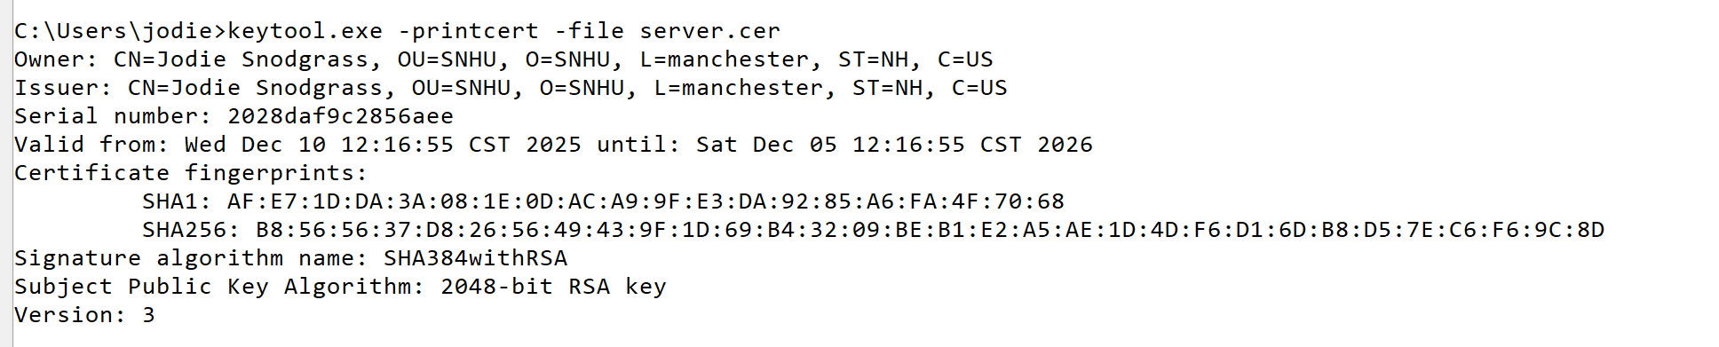

Deploy Cipher
Insert a screenshot below of the checksum verification.

I am unsure why I cannot produce a http for the checksum. I have edited the code and properties for https but I cannot find the http. I had the same issue in module 5 not finding the checksum but this time I have a successful build. 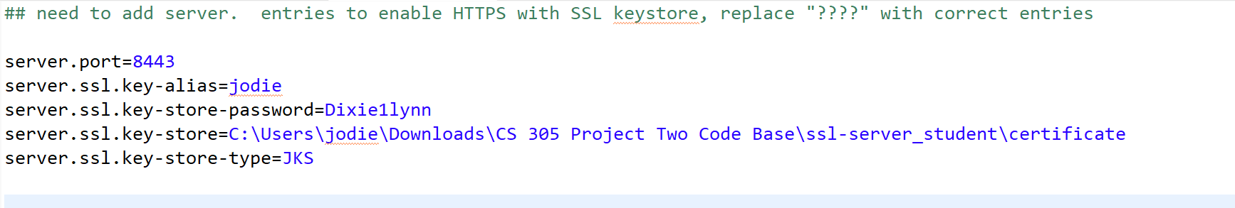
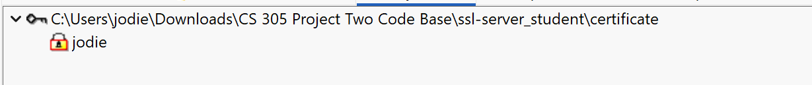

Secure Communications

I am sorry I am just unsure I have googled but nothing seems to help.

Secondary Testing
Insert screenshots below of the refactored code executed without errors and the dependency-check report.

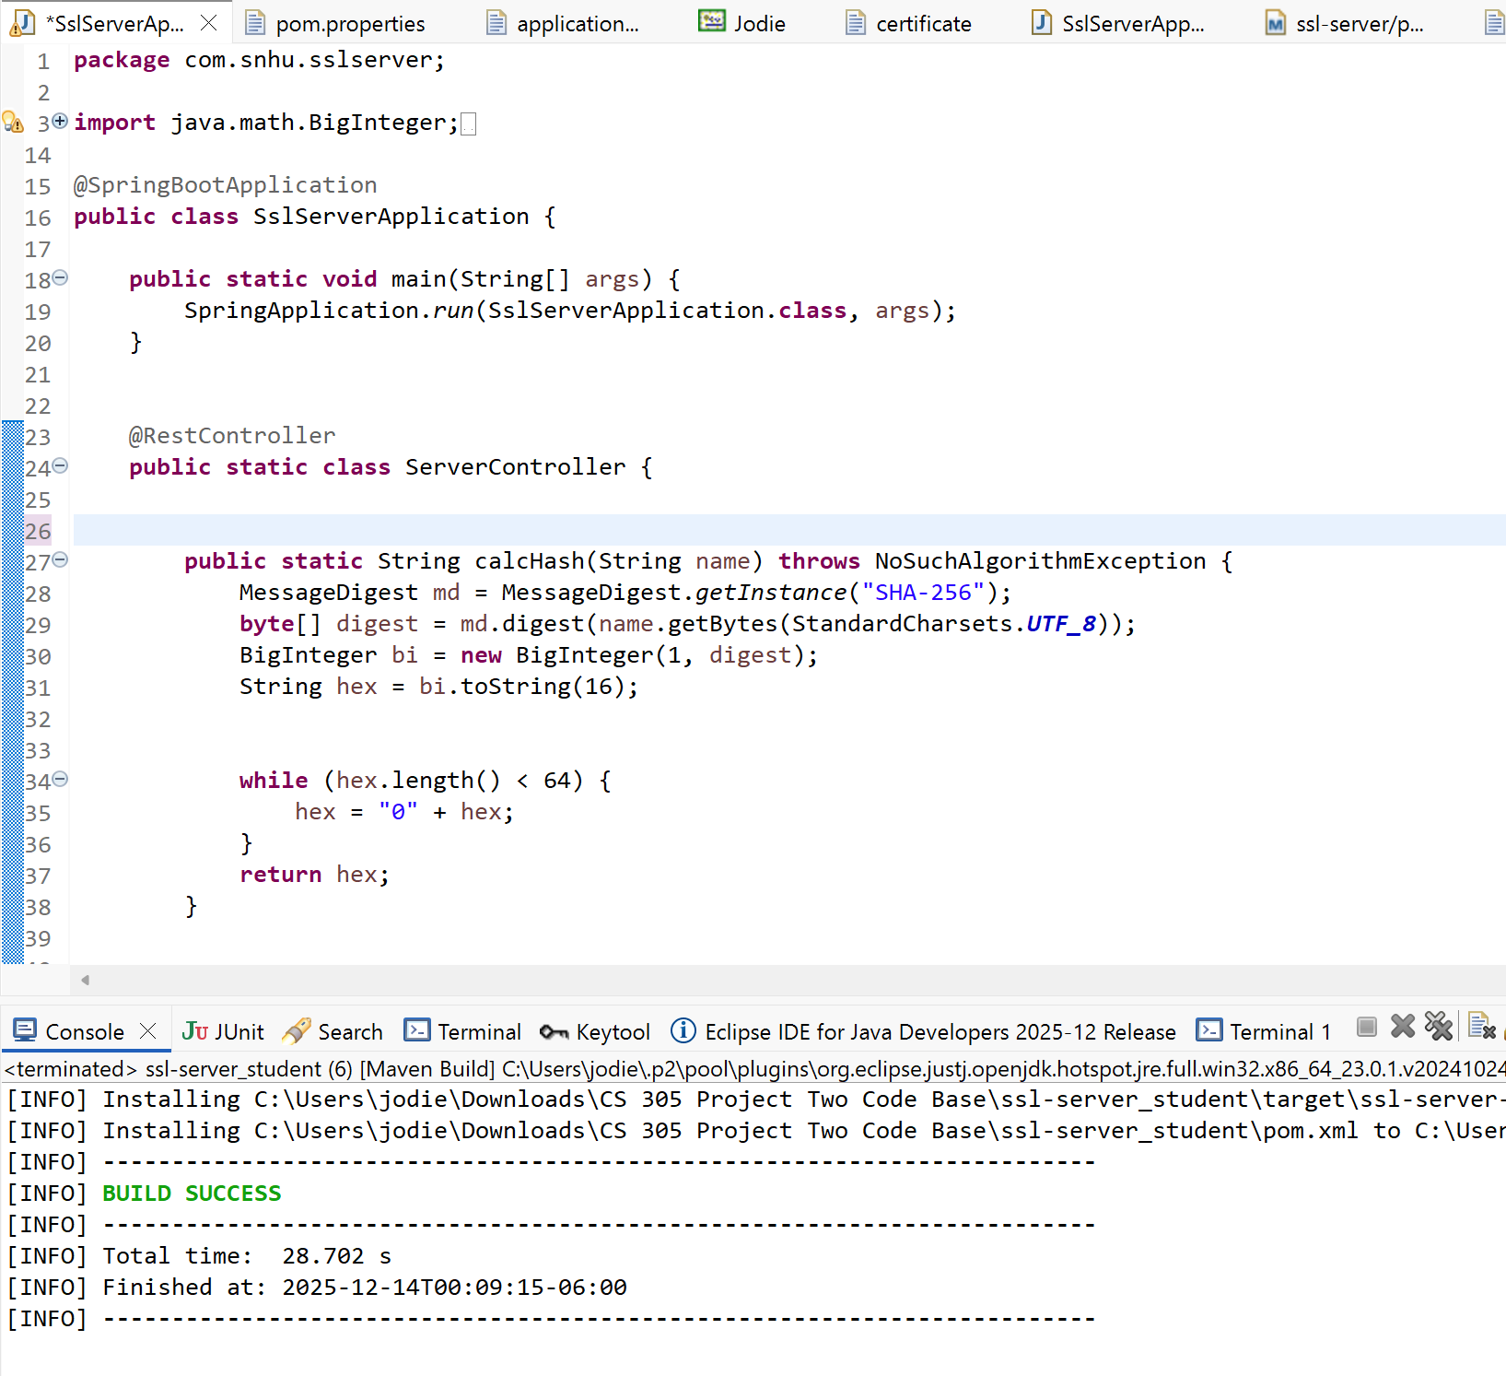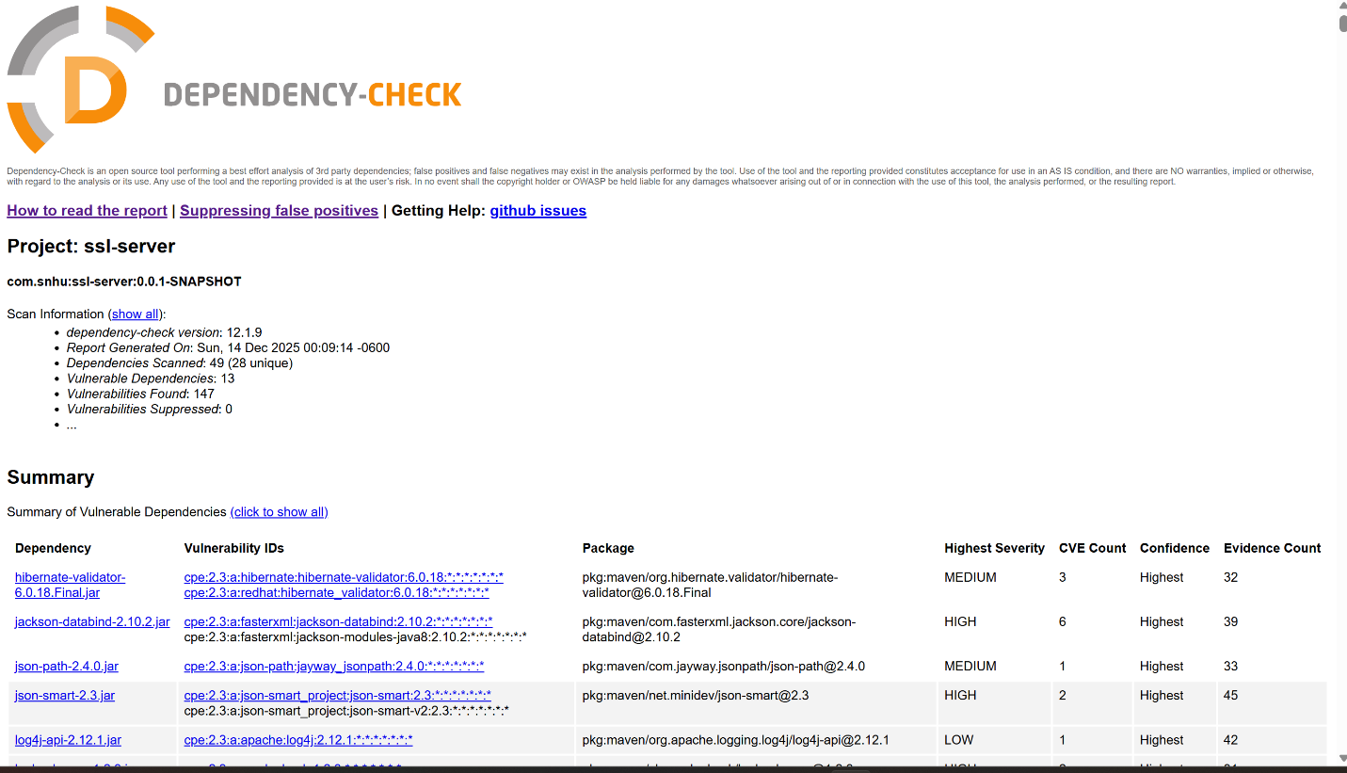

Functional Testing
Insert a screenshot below of the refactored code executed without errors.

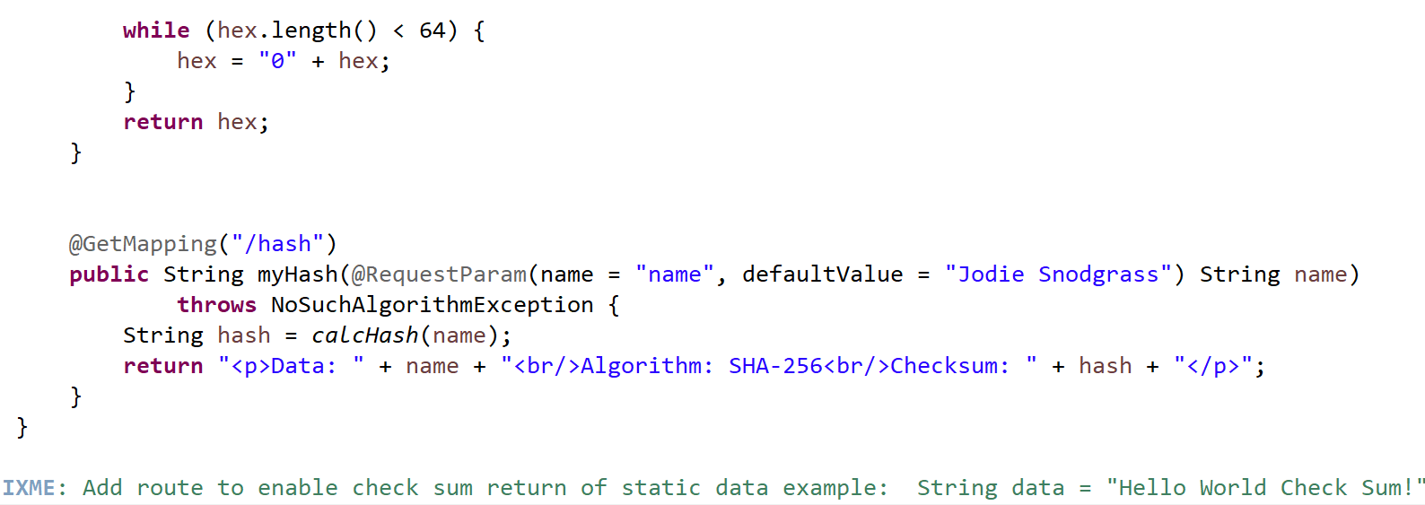

Summary

Refactoring the code I created a hash with SHA-256 which would allow encryption and password security with fixed length. The pom file was updated to reflect the latest software dependency check. The RestConroller. GetMapping. and RequestParam shows that a secure http hash should have been provided once ran but I could not find the http file. With the hash I should have been able to provide secure software with only key allowance protection. Each line of the code I looked at and thought about how this would add security or make it more vulnerable to attacks. I believe with my password protected certificate no should be able to access the file without the correct key. I did update the properties file to allow https but since I could not provide the http but it would have showed a secure link to the hash.

Industry Standard Best Practices
By updating the dependency check to the latest software being 12.1.9 we can be that any new possible threats can be seen. Updates should always be done to prevent any future attacks by having outdated software with possible bugs or leaks. There is always different ways to keep data secure a company must keep up with the latest security measures even if it would be to refactor the code. With constant secure data exchanges Artemis could gather a reputation of a good banking app making the company grow with more customers.

